Department of Veterans Affairs

Alert Watch and Response Engine (AWARE)

CPRS Integration

User Guide



**May 2014**

Version 1.0

Revision History

Note: The revision history cycle begins once changes or enhancements are requested after the document has been baselined.

| Date | Version | Description | Author |
| --- | --- | --- | --- |
| 5/6/2014 | .01 | Initial | B. Tjahjo |
|  |  |  |  |

**List of Tables**

Table 1 - Acronym and Abbreviations 5

**List of Figures**

Figure 1 – AWARE System Overview 7

Figure 2 - CPRS/AWARE Data Flows 8

Figure 3 – CPRS Tool Options 9

Figure 4 - Notification Types 11

Figure 5 - Select New Patient 12

Figure 6 – Address Now 12

Figure 7 - Location for Current Acivities 13

Figure 8 – TIU Template 13

Figure 9 - Not Authorized to Use Reminder Dialog 14

Figure 10 - Reminder Dialog Template 15

Figure 11 - Completed Reminder Dialog Template 16

Figure 12 – Progress Note 17

Figure 13 - Sign Note Now Menu 18

Figure 14 - Sign Note Dialog 18

Figure 15 - Signing Diagnosis and Service Dialog 19

Figure 16 - Address Later 20

Figure 17 - Process Alert 20

Figure 18 – Signing Follow-up Action 21

# Table of Contents

1. Introduction 5

1.1. Purpose 5

1.2. Project References 5

1.3. Acronyms and Abbreviations 5

2. System Summary 6

2.1. System Configuration 6

2.2. Data Flows 7

2.3. User Access Levels 8

3. CPRS/AWARE Integration User Guide 9

3.1. Enable notification for Critical Alerts 9

3.2. AWARE Follow-up Action 11

3.2.1. Address Now 12

3.2.2. Close and Address Later 19

4. Troubleshooting 21

# Introduction

The Computerized Patient Record System (CPRS) View Alerts package delivers notification of non-life threatening critical test results; however, it does not track whether providers take appropriate follow-up actions in response to the alerts. Currently, the only way to track follow-up actions on critical alerts is through manual review of individual patient records. The innovation Alert, Watch and Response Engine (AWARE) will track and monitor follow-up actions, and will identify certain critical lab and imaging test result alerts that lack timely follow-up.

CPRS integration for AWARE is the core part of the AWARE system. It is the basis for re-direction prompting of a patient’s provider(s) for processing timely follow-up actions on specific patient alerts involving patient safety. When these follow-up actions are completed, they help serve the Department of Veterans Affairs (VA) desired goals for providing excellent clinical care and matching patient safety measures for serving Veterans.

## Purpose

AWARE tracked critical alerts are defined using AWARE Knowledge-Based (KB) Editor application. KB Editor is intended for Clinical Application Coordinator (CAC) to define critical alerts required for specific site. CAC should refer to KB Editor user guide to create or modify existing tracked critical alert types.

The purpose of this document is to show CPRS AWARE user how to response follow-up prompt and complete follow-up actions for AWARE critical alerts through appropriate Reminder Dialog or/and Signing orders.

Audience for this manual will be typical CPRS users in VA facilities. This user guide assumes the average users will have a basic knowledge of how to use a computer and Windows GUI application in a healthcare setting. The user should have a fair understanding of the processes in the healthcare system of VA Medical Centers (VAMC).

## Project References

* Alert Watch and Response Engine User Interface Document
* Alert Watch and Response Engine System Design Document
* Alert Watch and Response Engine Requirements Specification Document
* Computerized Patient Record System User Guide

## Acronyms and Abbreviations

Table - Acronym and Abbreviations

|  |  |
| --- | --- |
| Term | Definition |
| AWARE | Alert Watch and Response Engine |
| CAC | Clinical Application Coordinator |
| COM | Component Object Model |
| CPRS | Computerized Patient Record System |
| DLL | Dynamic Link Library |
| KB | Knowledge-Based |
| GUI | Graphical user Interface |
| TIU | Text Integration Utility |
| VA | Department of Veterans Affairs |
| VAMC | VA Medical Center |
| VistA | Veterans Health Information Systems and Technology Architecture |

# System Summary

CPRS integration for AWARE is the core part of the AWARE system.Figure 1 and 2 below depict how the CPRS AWARE integration component related to other components in the AWARE eco-system.

## System Configuration

The bottom right panel in Figure 1 shows CPRS AWARE retrieves tracked critical alert definition from VistA instance. Alerts are generated in CPRS by means of abnormal lab results, screenings, treatments, and diagnostic services. During patient chart close-out event, AWARE Component Object Model (COM) object is called to direct user with follow-up action.



Figure – AWARE System Overview

## Data Flows

AWARE Dynamic Link Library (DLL) is integrated with CPRS (noted as 1a in the figure below). The AWARE DLL is a COM object called from CPRS at patient closeout during the selection of a different patient. Before this new patient selection is actually allowed, an alert tracker function in the AWARE DLL determines if a follow-up action(s) has been made for any of the tracked alert types for that user. If none has been made, a resulting prompting screen is presented to the user for another opportunity to address this issue. A choice can be made by the provider to do a follow-up action via subsequent re-direction to a specific CPRS reminder dialog.



Figure - CPRS/AWARE Data Flows

## User Access Levels

No new User Access Levels are required for AWARE version CPRS. They are similar as standard CPRS.

# CPRS/AWARE Integration User Guide

This user guide is not a CPRS user guide. This guide only covers AWARE follow-up action during patient chart close-out event. User should refer to CPRS User Guide for other CPRS related functionalities.

Support staff should provide user with the AWARE CPRS installer and instruction on how to launch AWARE CPRS by changing the shortcut’s parameters to point to the right VistA instance’s Server and Port.

## Enable notification for Critical Alerts

Unless enabled at a higher level, various notification types need to be enabled per user as seen from CPRS Tools menu, Options, Other CPRs parameters, and then Notifications tab as shown in Figure 3 and Figure 4.

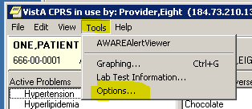

Figure – CPRS Tool Options

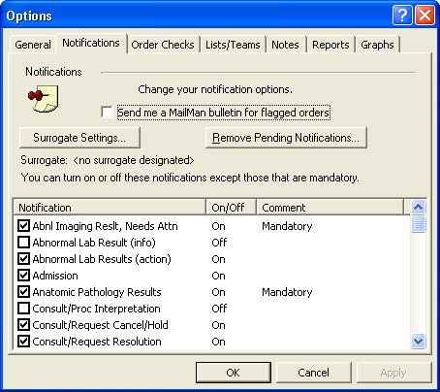

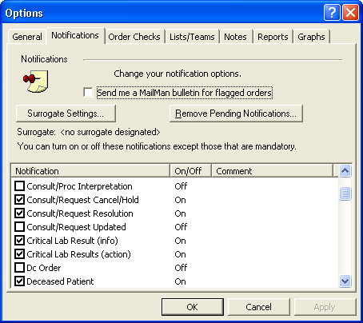

Figure - Notification Types

To track AWARE critical alert, turn on Critical labs results (action) and Abnl Imaging Reslt, Need Attn (action) .

## AWARE Follow-up Action

AWARE integration with CPRS is all about tracking critical alerts. The definition of AWARE tracked critical alert is defined by CAC by using Knowledge-Based (KB) Editor software.

When the tracked alerts are generated in CPRS by means of abnormal lab results, screenings, treatments, and diagnostic services, the provider will be prompted with follow-up action dialog during selecting a new patient (patient chart close-out event) as shown in Figure 5 and 6.

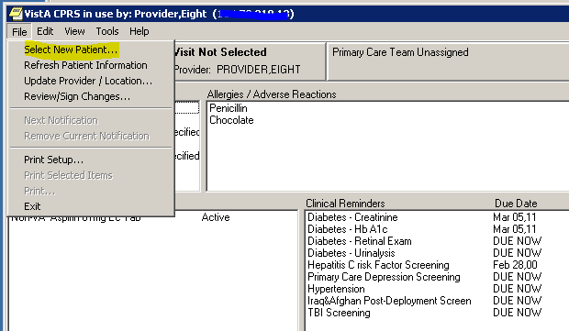

Figure - Select New Patient

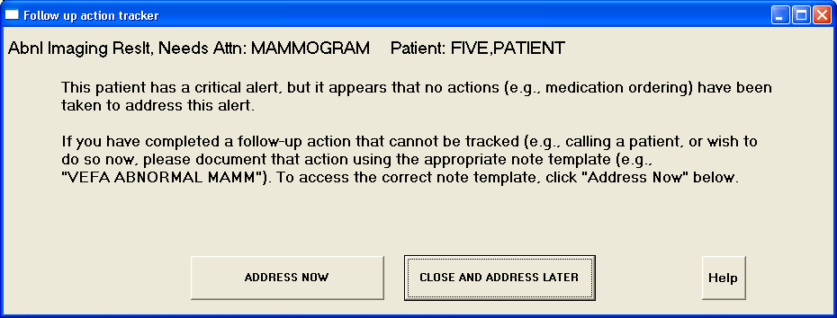

Figure – Address Now

### Address Now

Clicking the “Address Now’ button will bring up Visit Location dialog depicted in Figure 7.

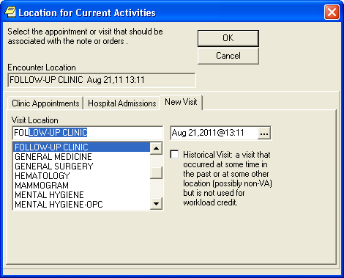

Figure - Location for Current Acivities

After selecting Visit location, user is directed to select TIU Template depicted in Figure 8.

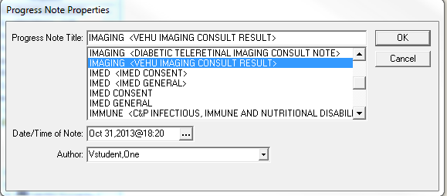

Figure – TIU Template

During AWARE initial setup, CAC made linkage to a TIU Template for AWARE reminder dialogs. This linkage may be provided for user, service, division, or system. Without this linkage assignment, the user will not be allowed to continue processing follow-up actions. Figure 9 depicts the “not authorized” error message dialog.

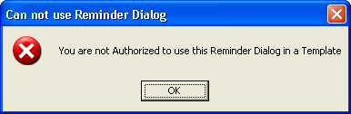

Figure - Not Authorized to Use Reminder Dialog

If the user is authorized to use the reminder dialogs linked to the selected TIU Template, the reminder dialogs should appear as shown in Figure 10.

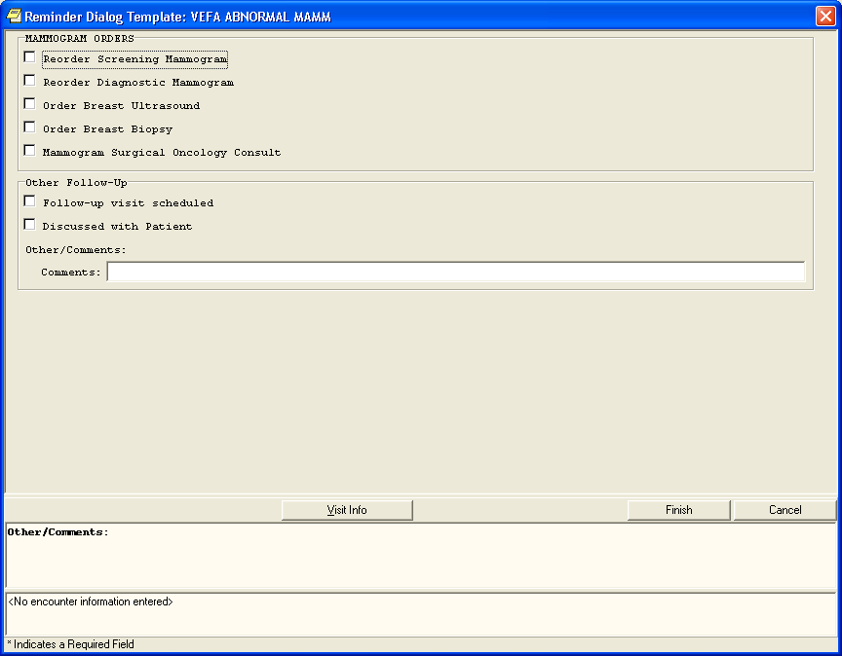

Figure - Reminder Dialog Template

Click and sign all appropriate orders and/or other follow-up actions. By passing this follow-up action will cause the follow-up prompt to reappear during patient chart closed-out event.

If no order follow-up actions are enabled but other non-order follow-up actions are, user will still allow to bypass the prompt on the next Patient Chart Closeout.

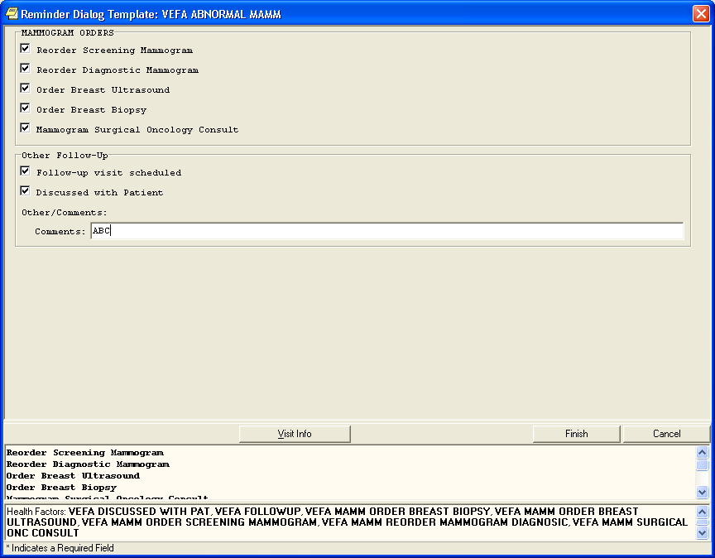

Figure - Completed Reminder Dialog Template

Click the “Finish” button to initiate follow-up actions. The Follow-up actions stored in the progress note should be generated as depicted in the right panel of Figure 12.

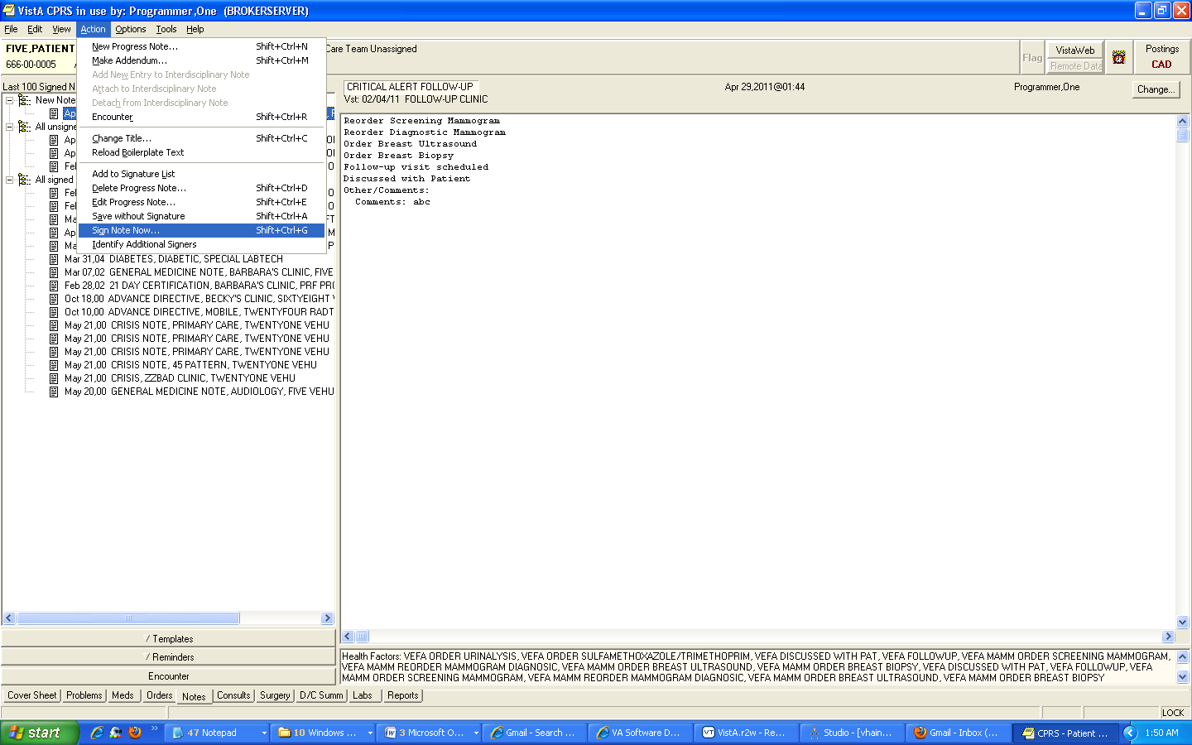

Figure – Progress Note

Sign note by selecting CPRS Action menu and click on Sign Note Now… as depicted in Figure 13 and Figure 14.

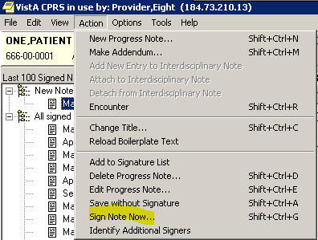

Figure - Sign Note Now Menu

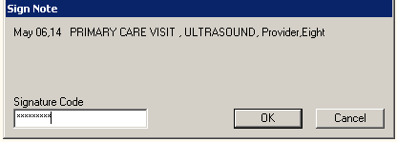

Figure - Sign Note Dialog

Diagnosis and service connected conditions may be required upon signing of orders as depicted in Figure 15.

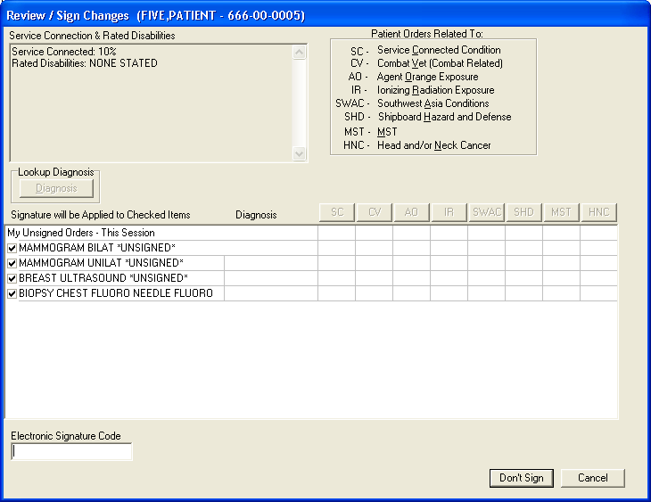

Figure - Signing Diagnosis and Service Dialog

Pertinent Orders to satisfy Follow-up Actions do not have to be made through the follow-up action prompt on Patient Chart Closeout . These can be done independently and when completed those orders will satisfy the follow-up action requirements.

If an unsigned orders still exist, the follow-up action prompt will reappear during Patient Chart Closeout event.

### Close and Address Later

User may elect to address follow-up actions later when prompted with Follow-up action dialog (Figure 16). In this case, user should process the alert as depict in Figure 17. This will cause renewal of the alert.



Figure - Address Later

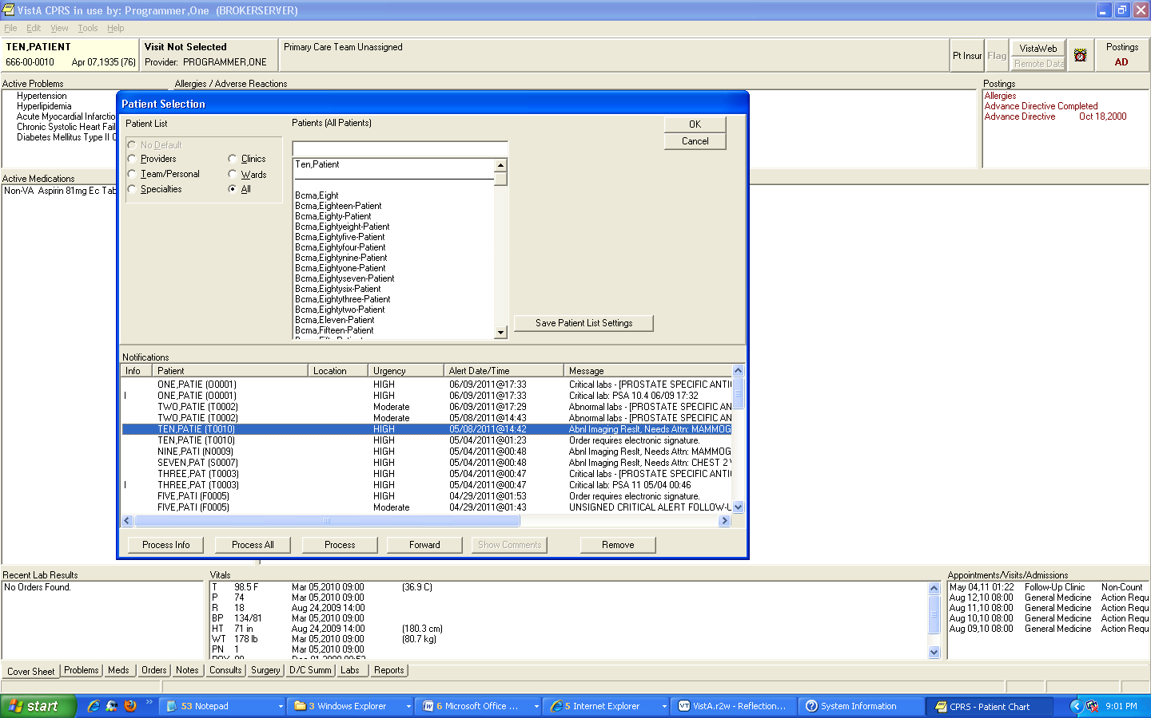

Figure - Process Alert

Sign the follow-up action to complete the process as depicted in Figure 18.

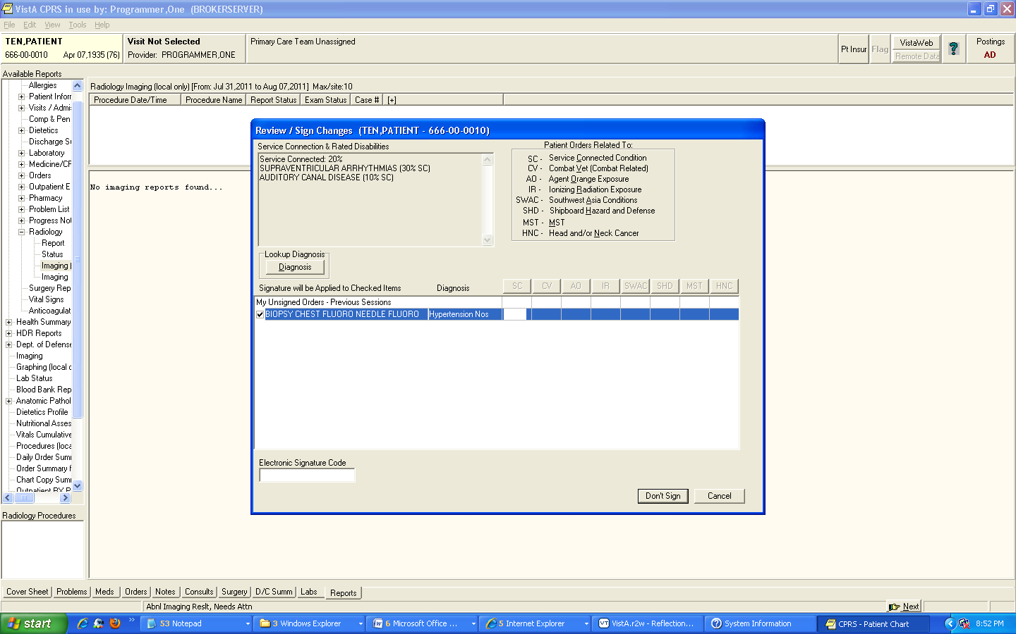

Figure – Signing Follow-up Action

# Troubleshooting

The AWARE project team is working to develop a frequently asked questions (FAQs) section for this User Guide, which will contain user-related troubleshooting tips, known issues, and anomalies. This section will be made available as those items are realized and documented.